**Lab A week 11**

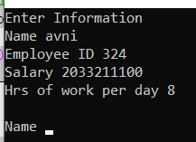Q1. #include<stdio.h>

struct employ

{

char name[20];

int sal,emp_id;

}e[10];

int main()

{

int hr,salary;

printf("Enter Information \n");

int i;

for(i=1;i<=10;i++)

{

printf("Name ");

scanf("%s",&e[i].name);

printf("Employee ID ");

scanf("%d",&e[i].emp_id);

printf("Salary ");

scanf("%d",&e[i].sal);

printf("Hrs of work per day ");

scanf("%d",&hr);

if(hr>=8 && hr<10)

e[i].sal+=50;

else if(hr>=10 && hr<12)

e[i].sal+=100;

else if(hr>=12)

e[i].sal+=150;

else;

printf("\n");

}

printf("\nPrinting Information \n ");

for(i=1;i<=10;i++)

{

printf("%s \t \t %d \t %d",e[i].name,e[i].sal,e[i].emp_id); printf("\n");

}

return 0;

}

Q2. #include<stdio.h>

struct measure

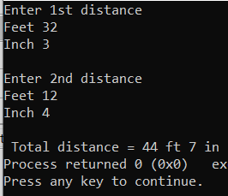{

int ft,inch;

}a,b;

int main()

{

int feet,in;

printf("Enter 1st distance \n");

printf("Feet ");

scanf("%d",&a.ft);

printf("Inch ");

scanf("%d",&a.inch);

printf("\nEnter 2nd distance \n");

printf("Feet ");

scanf("%d",&b.ft);

printf("Inch ");

scanf("%d",&b.inch);

feet = a.ft + b.ft;

in = a.inch + b.inch;

printf("\n Total distance = %d ft %d in",feet,in); return 0;

}

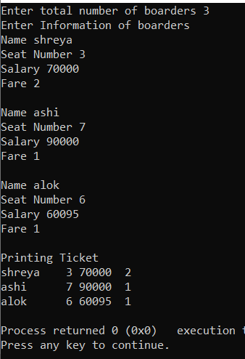Q3. #include<stdio.h>

struct boat

{

char name[20];

int seat_num,sal,fare;

}b[100];

int main()

{

int n,i;

printf("Enter total number of boarders "); scanf("%d",&n);

printf("Enter Information of boarders \n");

for(i=0;i<n;i++)

{

printf("Name ");

scanf("%s",&b[i].name);

printf("Seat Number ");

scanf("%d",&b[i].seat_num);

printf("Salary ");

scanf("%d",&b[i].sal);

printf("Fare ");

scanf("%d",&b[i].fare);

printf("\n");

}

printf("Printing Ticket \n");

for(i=0;i<n;i++)

{

printf("%s \t %2d %2d %2d",b[i].name,b[i].seat_num,b[i].sal,b[i].fare); printf("\n");

}

return 0;

}

Q4. #include<stdio.h>

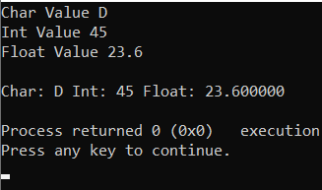struct A

{

char ch[20];

int i;

float f;

}a;

struct A read()

{

printf("Char Value ");

scanf("%s",&a.ch);

printf("Int Value ");

scanf("%d",&a.i);

printf("Float Value ");

scanf("%f",&a.f);

}

void show(struct A a)

{

printf("\nChar: %s",a.ch);

printf("\tInt: %d",a.i);

printf("\tFloat: %f \n",a.f);

}

int main()

{

read();

show(a);

return 0;

}